**CSC 131 - Computer Software Engineering**

**Fall 2021 – Section 01**

Software Design Document (SDD) - Project Deliverable #3

Team Data Pirates

Team Members: Ryan Farruggia, Bikram Singh, Raphael Guerrero, Catalina Wanchai, Mahroona Yasar, Tran Chi, David Quintanilla

**CalTrans PDF Management Tool**

**Table of Contents**

1. Introduction
   1. Project Overview
   2. Major Goals of the System
2. Functional Requirements
3. Data Design
   1. Entities
   2. Relationships
4. Architectural Design
5. Detailed Design
   1. Use Case Diagram #1
   2. Use Case Diagram #2
6. User Interface Design
   1. Interface Design Description
   2. Figure 6.1a: Project Summary
   3. Figure 6.1b: Project Summary Dropdown Boxes
   4. Figure 6.2: SWCA & BMP Finding Summaries
   5. Figure 6.3: Stormwater Contract Administration Review
   6. Figure 6.4: Construction Site BMP Review
   7. Figure 6.5: Report Certification
   8. Figure 6.1c & 6.1d: Report Certification
7. Technology and Tools
8. Assumptions and Constraints
   1. Assumptions
   2. Constraints and Limitations
9. Team Member’s Roles and Approvals
   1. Member Roles
   2. Signatures and Approvals
10. **Introduction**
    1. Project Overview

This project is a restructure of the existing Caltrans project construction stormwater review report. The project is a monthly inspection used by the Headquarters and some Districts to keep track of the number of deficiencies identified, and this monthly inspection is conducted by the Construction Stormwater Coordinators. The report is presented to the Resident engineer and contractor. They addressed and corrected the deficiencies identified.

* 1. Major goals of the system: providing users a friendly and convenient working environment.
     1. The contractor can provide photos and measurement descriptions of the corrections and ensure that all active construction projects meet the compliance criteria.
     2. Increase efficiency for the user during work hours and reduce limitations of the previous version.
     3. The program can run on Mac, Windows, and Linux systems.
     4. The Project meets the requirements and needs of the users like the ability to unlock the document with user passcode.
     5. There is the auto population of the standard specification and specification language when BMP category and BMP Type are selected.
     6. The system is designed to show the total number of findings.

1. **Functional Requirements**
   1. Need to add function to the “Add Finding” button to insert fillable entries that can be edited on page 2.
   2. Finding number must be decremented every time user clicks “Delete Finding” on page 2.
   3. Each additional finding must have a button that removes it from the PDF.
   4. When duplicating a page, find a way not to duplicate previous findings/pictures.
   5. Take a password specific for that document for re-access when form is first opened
   6. Uploaded photos should downscale resolution to save data on import.
   7. Form should autocomplete certain sections when information is entered.
   8. Applicable text boxes should have dropdowns that prompt relevant data.
   9. “Lock Report” functionality should prevent further editing of the form.
2. **Data Design**

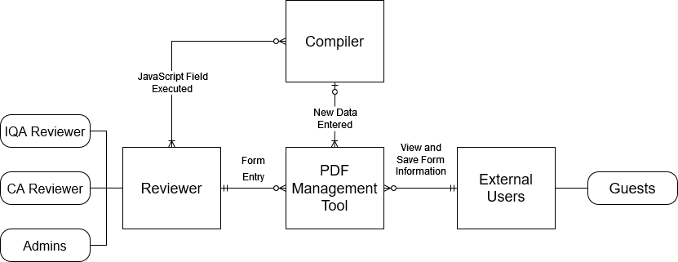

3.1. Description

3.1.1. Entities

* *PDF Management Tool:* Editable and lockable/unlockable by IQA Reviewers, Corrective Action Reviewers, and other CalTrans Administrators; viewable and savable by external users (guests).
* *Reviewer:* An IQA Reviewer, Corrective Action Reviewer, or other CalTrans Administrator with full access to edit and manipulate all information in the PDF Management Tool.
* *External Users:* Guest users with very limited access to the locked version of the PDF Management Tool, ability to save and view information.
* *Compiler:* The integrated compiler that functions in conjunction with the PDF Management Tool that runs JavaScript code and sends the compiled/calculated data back to the management tool when new information is entered.

3.1.2. Relationships

* *Reviewer and PDF Management Tool:*
  + A Reviewer must submit at least one form entry.
  + Requires that the reviewer send at least one instruction to the tool for data to be processed properly.
* *Reviewer and Compiler:*
  + Any Reviewer or administrator can edit and send code directly to the integrated compiler. Reviewers can send zero to many instructions to the compiler for assembly.
  + Requires that one or more Reviewers save the provided code at least once after entry is complete.
* *External Users and PDF Management:*
  + External Users (guests) can view and save zero to many locked versions of the PDF Management Tool.
  + Nothing is functionally required from External Users for the tool to execute properly.
* *Compiler and PDF Management Tool:*
  + The compiler can send one finished code compilation to the management tool at a time.
  + Nothing is functionally required from the PDF Management Tool for the compiler to receive/update information.

1. **Architectural Design**

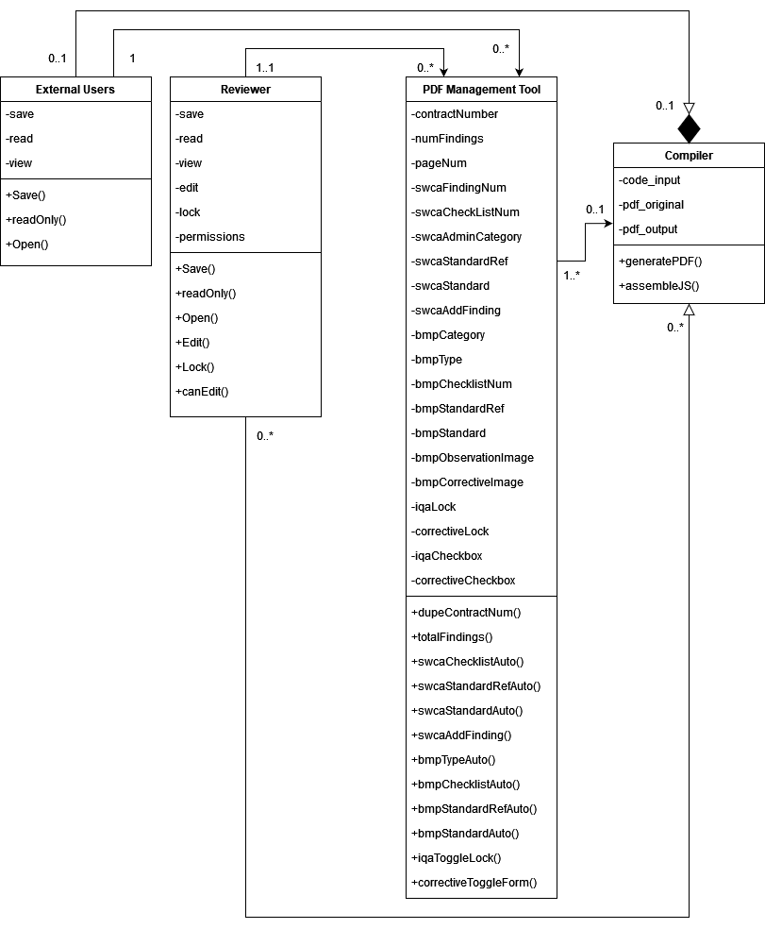

1. **Detailed Design**

* See Sequence Diagrams below for Use Cases #1 and #2.

Use Case #1

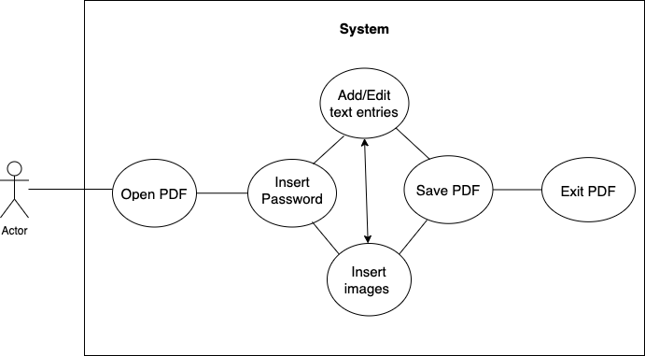

Use Case #2

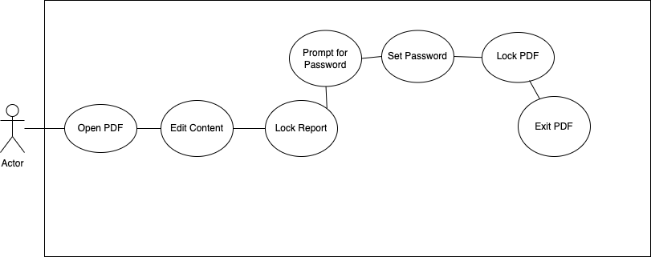

1. **User Interface Design**
   1. The Interface Design describes internal and external program interfaces. Interface designs are based on the information obtained from the analysis models. Use the Use Case Model and Sequence diagram to capture the interface design. Show menus, submenus, buttons, text boxes, check boxes, lists, links, tables.

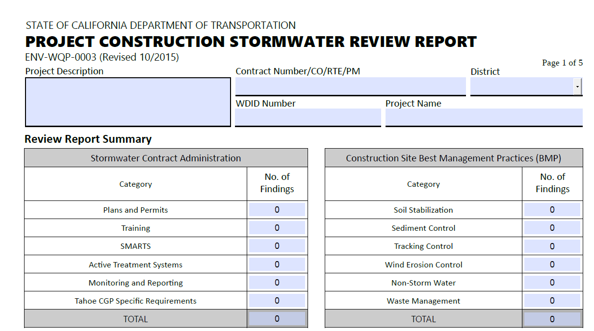

Figure 6.1a: Project Summary

* This is part of the project summary page. It has several blank boxes the user may left click and fill out so they may record information of the summary of their project.

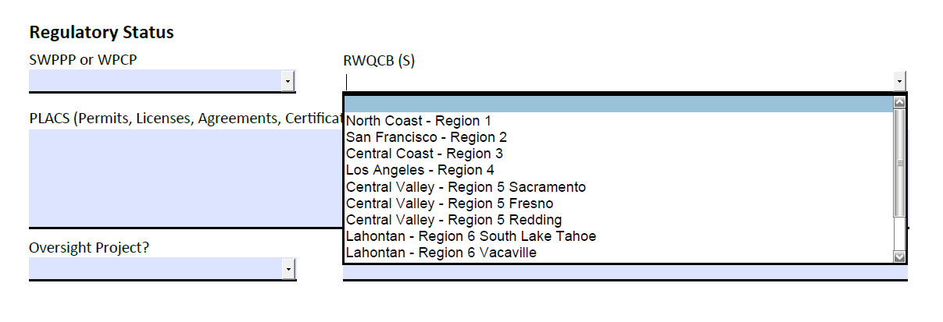

Figure 6.1b: Project Summary Dropdown Boxes

* Certain boxes have drop down menus that allow users to quickly fill boxes with information relevant to their respective topic. The “RWQCB(s)” dropdown arrow depicted above will list several locations to choose from once clicked, as shown above.

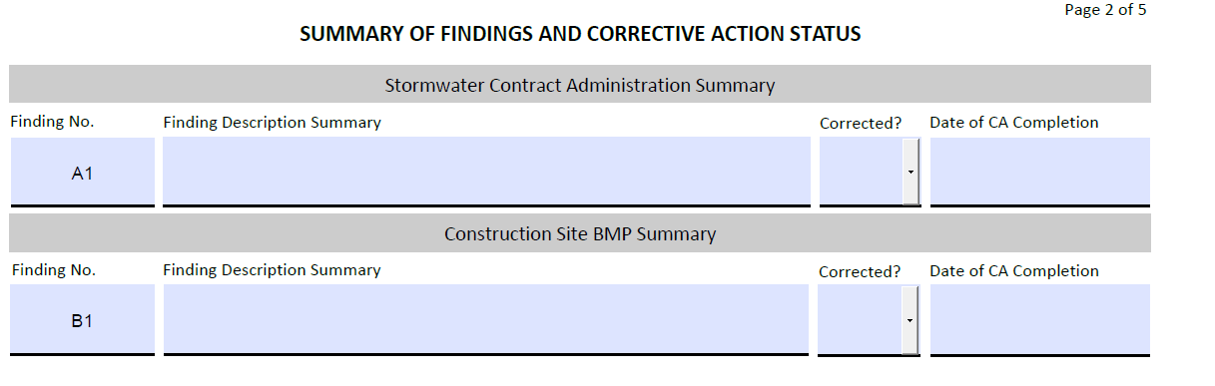

Figure 6.2: SWCA & BMP Finding Summaries

* This second page consists of the multiple findings split into either the Stormwater Contract Administration category or the Construction site BMP category. Each row will contain interactive boxes to fill information relevant to their respective categories, including one drop down with the options to answer the question whether the finding has been corrected or not.

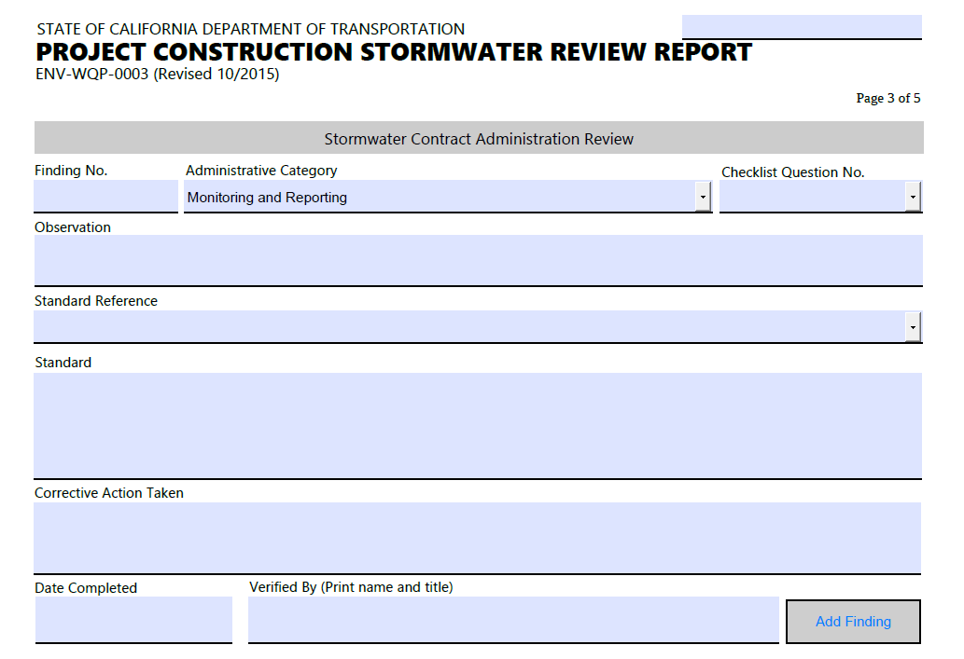

Figure 6.3 Stormwater Contract Administration Review

* This page is filled with text boxes the user may fill out with relevant information.

Figure 6.4 Construction Site BMP Review

* This page is filled with text boxes and dropdowns the user may fill out information relevant to their respective topics. Clicking on one of the empty grey squares will give you an option to insert an image stored inside your pc. The “Add 2nd Observation Photo” button will allow you to add additional photos. The “Hide Image” button allows you to hide images so that document storage size is reduced when saved. “Delete image field” will remove an image you inserted into the document as well as the previously mentioned buttons and observation text box. The “Add Finding” button will have the same function as the previous “Add Finding” button on page 3.

Figure 6.5 Report Certification

* This page contains several fillable text boxes that allow you to input your name and signature as well as the date the report has been completed. There are also checkboxes that can be checked once left clicked for the “Review Report Certification” as well as “Corrective Action Certification”. The “show instructions” button at the bottom will reveal text showing what is to be done with the document after completion.

Figure 6.1b and 6.1c Report Certification

* The two buttons labeled with “Lock Report” function to lock the document so it may not be accessed unless you enter the password that was created when the document was originally locked. The first prompt will be to ask if you are sure you will want to lock the document followed by options yes, no or cancel. If no or cancel is selected, the prompt will be exited. However, if yes is selected you will be given a prompt to enter a custom password you may use to access the document next time you open it.

1. **Technology and Tools**

* *Mac/Windows Operating System:* Our team’s operating systems consisted mainly of these two and Windows is the main system used by the client which allows us to better cater to their needs/preferences.
* *ECS Labs/Servers:* To test this software, advanced access to tools and software developed by Adobe was necessary and thus required access to the school’s engineering labs which have proper licensing for experimentation and testing.
* *Visual Studio Code:* A highly verbose and extremely useful text editor that allowed for programming in multiple languages and allowed for enhanced debugging, syntax checking, and code linting.
* *Adobe Acrobat Pro DC:* An advanced PDF editing software that allows for scripting, compression, and size optimization.
* *Eclipse IDE:* An IDE primarily used for programming Java applications to allow the team to use their skills in Java to understand the architecture of the project’s system more easily.
* *Java Programming Language:* One of two primary languages used to program the project and manipulate data on PDF files.
* *JavaScript Programming Language*: The second primary language used to add scripts to data on PDF files.

1. **Assumption and Constraints**
   1. Constraints (Unordered):
      1. *Time Constraint*: This project has been set for completion by the end of the Fall 2021 academic year.
      2. *Cost Constraints*: Although no legal form of currency was used in this project, one form of cost came through the form of man hours used in the completion of the project. Divided into several sections by the Project manager (Ryan Farruggia), the division of man hours and time spent on the project was a constraint on some members.
      3. *Scope Constraints*: Project must abide by the stakeholder demands to enhance the given template of the PCSRR.
      4. *Quality Constraints*: Given the stakeholders previous request of enhancing the PCSRR, some quality constraints of the project have derived from no previous knowledge of the PCSRR and editing software.
   2. Assumption and Limitations (Unordered):
      1. *Software Limitations:*Using several different platforms for software development led to several errors throughout the design process which allocated stress towards the Time Constraint on the project.
      2. *Knowledge Limitations*: Although familiar with several different languages, allocating time to incorporate java for the use of PDF manipulation was a great stress on the project because most members were unfamiliar with the API required to code the project.
      3. *School Limitations*: This project required allocating time from other classes to fulfill several requirements within the scope of the project. Having obligations such as other assignments, projects, and exams, the design of our software was limited by team members obligations to their schoolwork load.
      4. *Equal Contribution Assumptions*: Most members were unable to contribute anything substantial to the project because of their lack of knowledge on the subject and thus caused great strain on two members to complete the vast majority of the project.
      5. *Stakeholder Assumptions:*Although given several sample documents throughout the semester about Caltrans PCSRR, the required previous knowledge of understanding the PCSSR and terminology used in the form was preferred by the client.
2. **Team member’s Roles and Approvals**
3. Team member’s roles include to work on the design document and on the project. All team members were new to some of the concepts to work on the project, so we were tasked with learning and using new techniques for it. Team leader plans, leads, and manages the project and teamwork loads. Also determining the methodology used on the project and establishing a project schedule and planning each phase and all the team members worked together to complete the design document as well as the final program design layout.
4. Team member’s signatures and date

|  |  |  |
| --- | --- | --- |
| Member’s | Signatures | Date |
| Ryan Farruggia | Ryan Farruggia | 12/03/2021 |
| Bikram Singh | Bikram Singh | 12/05/2021 |
| Mahroona Yasar | Mahroona | 12/03/2021 |
| Catalina Wanchai | Catalina Wanchai | 12/06/2021 |
| Tran Chi | Tran Chi | 12/06/2021 |
| Raphael Guerrero | Raphael Guerrero | 12/06/2021 |
| David Quintanilla | *David Quintanilla* | 12/06/2021 |